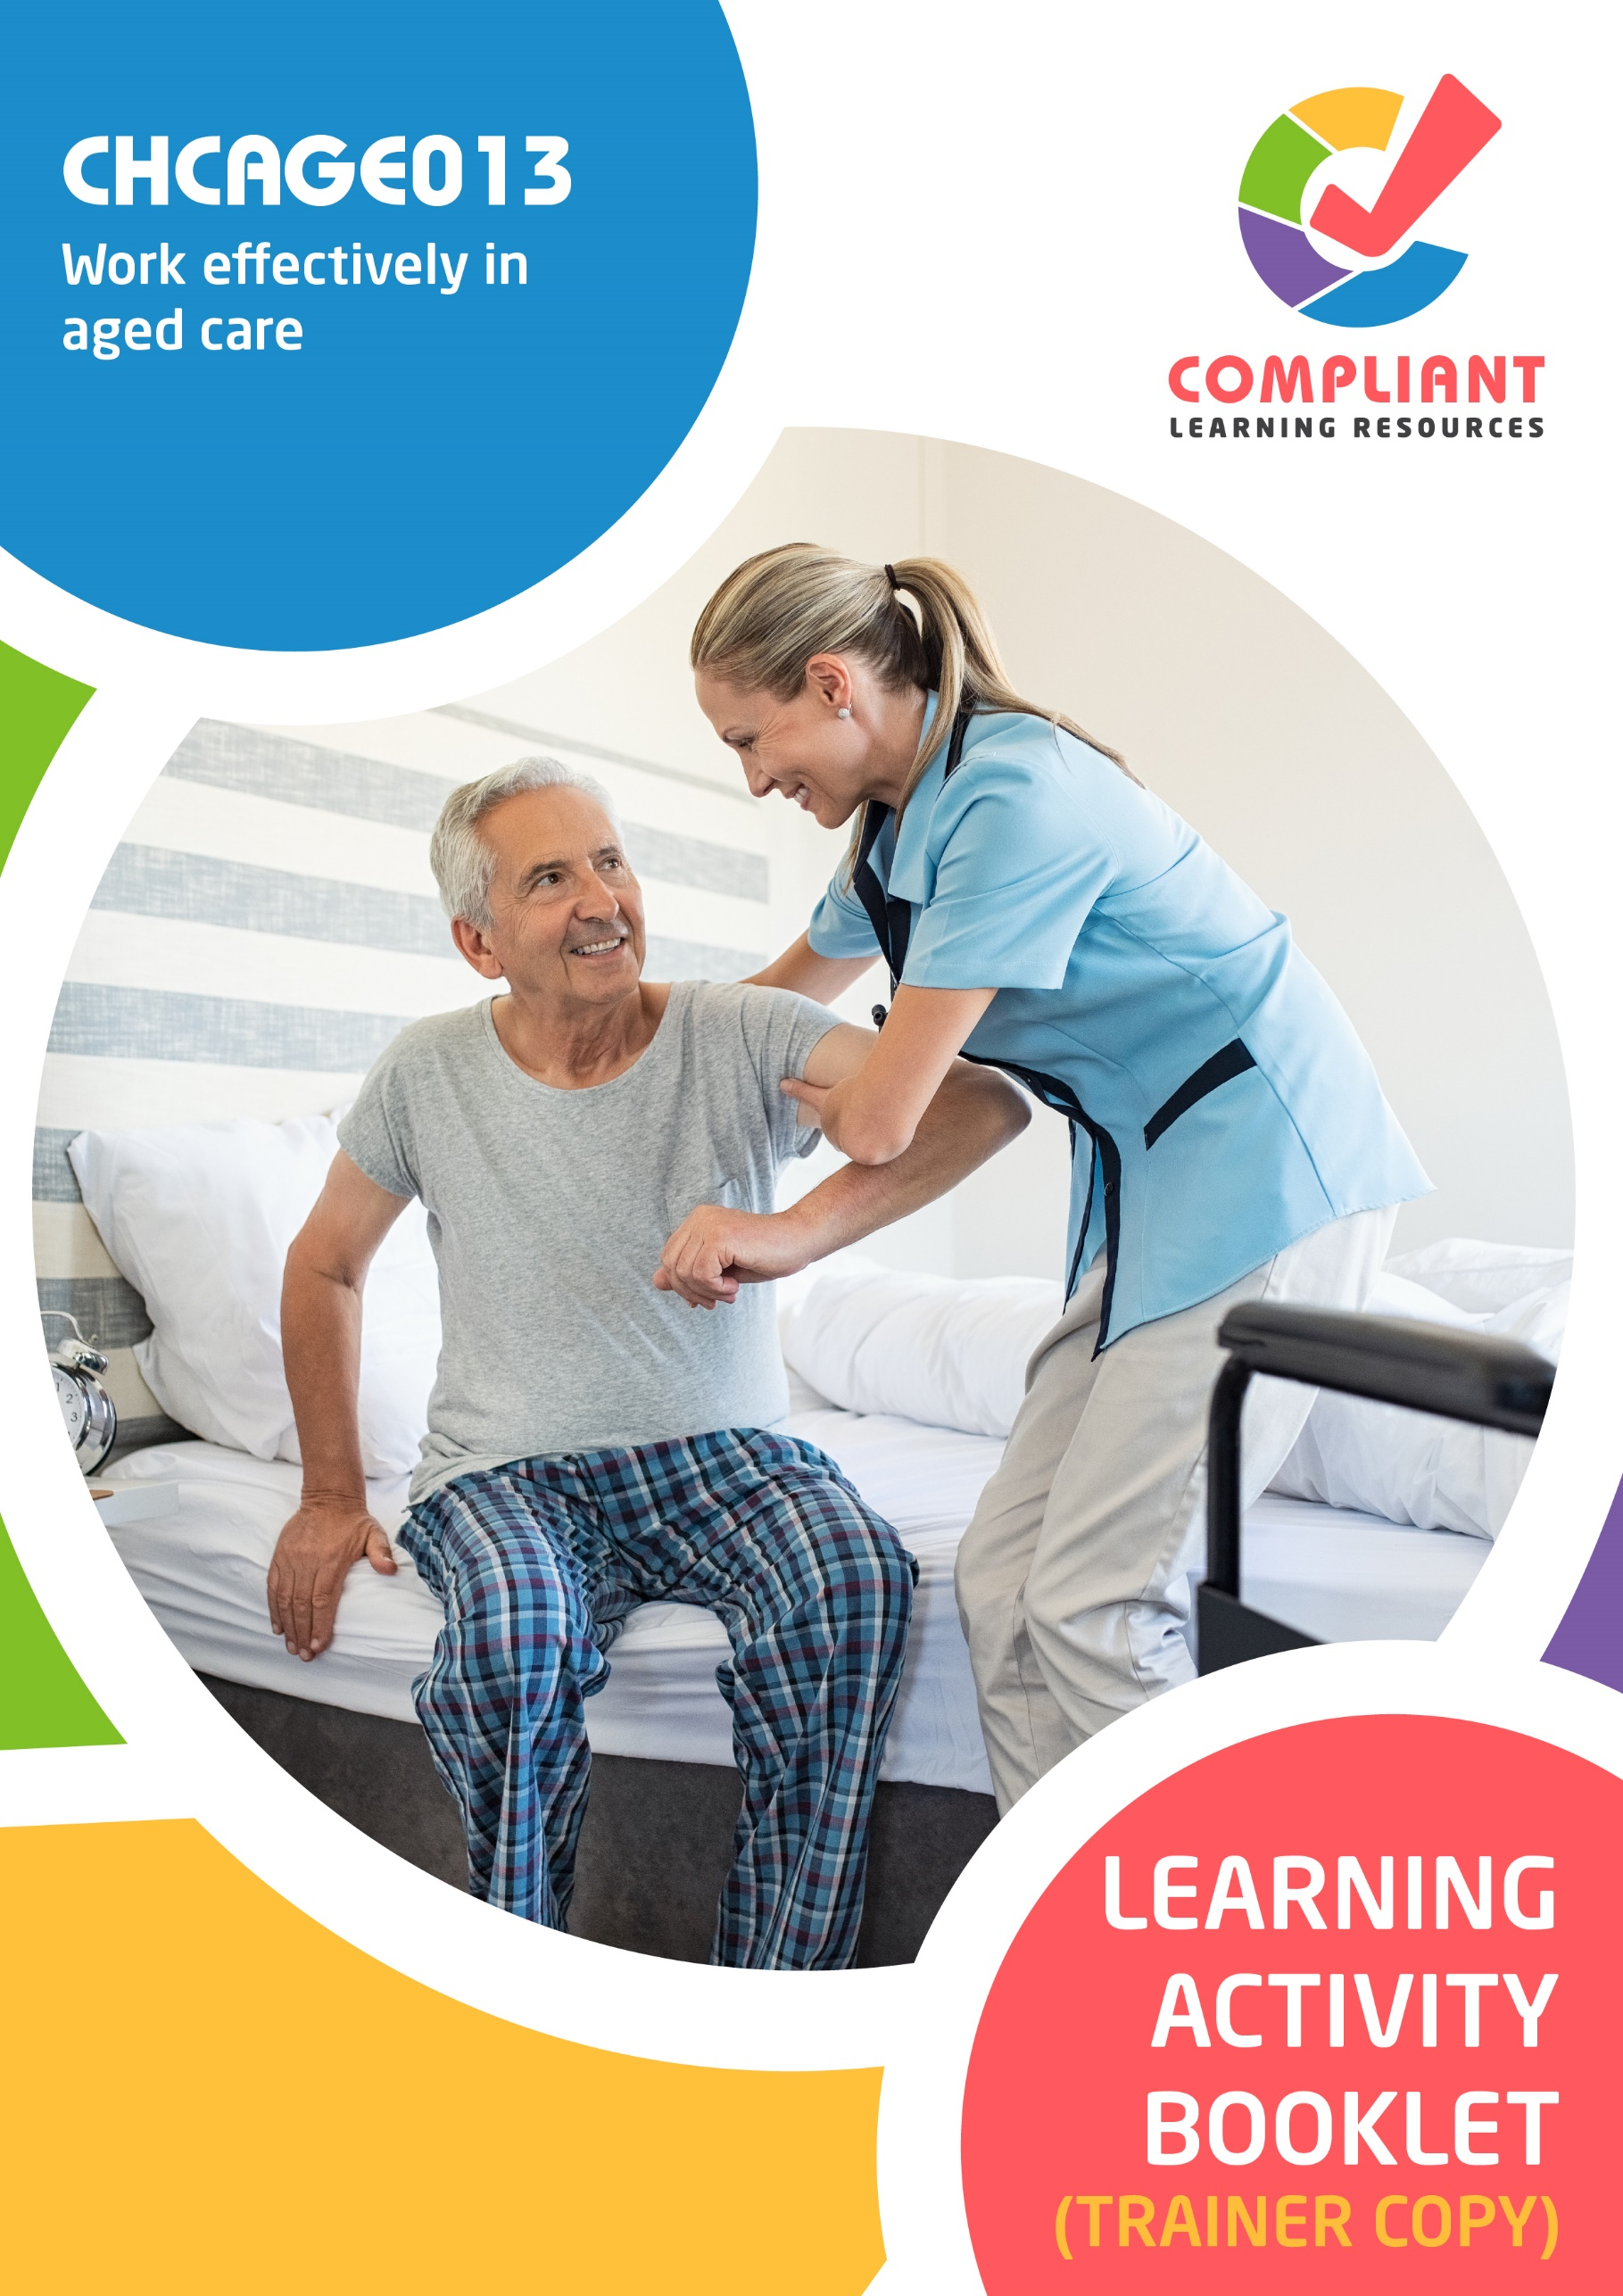

**Copyright**

This document was developed by Compliant Learning Resources.

© 2023 Compliant Learning Resources.

All rights reserved.

No part of this publication may be reproduced, stored in a retrieval system, or transmitted in any form or by any means, electronic, mechanical, photocopying, recording, or otherwise without the prior written permission of Compliant Learning Resources.

**Version Control & Document History**

|  |  |  |
| --- | --- | --- |
| **Date** | **Summary of Modifications** | **Version** |
| 4 January 2023 | Version 1.0 released for publishing | 1.0 |

# Table of Contents

Overview 4

Trainer Instructions 5

Learner Instructions 6

Learner Information 6

Trainer Information 6

Resources Required 7

Work Health and Safety 7

Reasonable Adjustment 8

Contextualisation 9

Formative Activities 10

I. Meet Job Role Requirements 10

Activity 1.1 10

Activity 1.2 11

II. Work Within Organisational Requirements 12

Activity 2.1 12

Activity 2.2 13

Activity 2.3 14

III. Work Within an Aged Care Context 15

Activity 3.1 15

Activity 3.2 16

Activity 3.3 17

IV. Implement Self-Care Strategies 18

Activity 4.1 18

Activity 4.2 19

# Overview

**CHCAGE013 - Work effectively in aged care (Release 1)**

This unit describes the performance outcomes, skills and knowledge required to work effectively in an aged care work context. The unit covers meeting job requirements, complying with organisational requirements and working in an aged care sector context.

This unit applies to individuals who work with older people in a range of community services and health contexts. Work performed requires some discretion and judgement and will be carried out under regular direct or indirect supervision.

The skills in this unit must be applied in accordance with Commonwealth and State/Territory legislation, Australian standards and industry codes of practice.

No occupational licensing, certification or specific legislative requirements apply to this unit at the time of publication.

**A complete copy of the above unit of competency can be downloaded from the TGA website:**

<https://training.gov.au/Training/Details/CHCAGE013>

# Trainer Instructions

This Learning Activity Booklet contains formative activities that learners will complete in the classroom or a similar environment.

These formative activities include knowledge questions to test learners’ underpinning generic knowledge and practical activities to test their skills relevant to the unit/s of competency.

These formative assessments are used by trainers to complement both the learning and training processes, and to evaluate how learners are progressing throughout these processes.

**IMPORTANT:**

**The completion of the formative assessments and learning activities included in this workbook DOES NOT lead to a Qualification or a Statement of Attainment (SOA).**

Reasonable adjustment applies here, and while the majority of learners will complete this assessment as a written assessment, verbal assessment may be an option for those who need it. The assessor must use the marking guide as the principal marking tool unless a reasonable adjustment is demonstrated.

The Learning Activity Booklet (Trainer Copy) provides model answers to all the questions, setting out which key responses must be included as well as indicating where flexibility is acceptable.

The number of responses required is specified in each assessment task to avoid ambiguity. In these cases, the model answer will provide a list of possible answers. For instance, if a question requires the learner to list three examples, then their response must include three of the items listed in the model answer.

# Learner Instructions

This Learning Activity Booklet contains formative activities that learners will complete in the classroom or a similar environment.

These formative activities include knowledge questions to test your underpinning generic knowledge and practical activities to test your skills relevant to the unit/s of competency.

These formative assessments are used by your trainer to complement both the learning and training processes, and to evaluate how you are progressing throughout these processes.

You may reference your Learner Guide and other learning materials to complete the activities included in this workbook.

**IMPORTANT:**

**The completion of the formative assessments and learning activities included in this workbook DOES NOT lead to a Qualification or a Statement of Attainment (SOA).**

## Learner Information

|  |  |
| --- | --- |
| Learner name |  |
| Phone |  |
| Email |  |

## Trainer Information

|  |  |
| --- | --- |
| Trainer name |  |
| RTO name |  |
| RTO phone |  |
| RTO email |  |

# Resources Required

Resources needed to complete activities included in this workbook include:

* Computer with Internet, email access, and a working web browser
* Installed software: MS Word, Adobe Acrobat Reader
* Learner guide

# Work Health and Safety

Both the trainers and learners have duty of care in ensuring that the learning environment is free from hazards that may pose risks to their health and safety.

According to WHS legislation, trainers and learners must take reasonable care while undertaking the activities included in this workbook in the learning environment.

# Reasonable Adjustment

‘Reasonable adjustment’ in VET is the term applied to modifying the learning environment or making changes to the training delivered to assist a learner with a disability. A reasonable adjustment can be as simple as changing classrooms to be closer to amenities or installing a particular type of software on a computer for a person with vision impairment.

**Why make a reasonable adjustment?**

We make reasonable adjustments in VET to make sure that learners with disabilities have:

* The same learning opportunities as learners without disabilities, and
* The same opportunity to perform and complete assessments as those without disabilities.

**Reasonable adjustment applied to participation in teaching, learning, and assessment activities can include:**

* Customising resources and assessment activities within the training package or accredited course
* Modifying the presentation medium
* Learner support
* Use of assistive/adaptive technologies
* Making information accessible both before enrolment and during the course
* Monitoring the adjustments to ensure learner needs continue to be met

**Assistive/Adaptive Technologies**

Assistive/adaptive technology means ‘software or hardware that has been specifically designed to assist people with disabilities in carrying out daily activities’ (World Wide Web Consortium - W3C). It includes screen readers, magnifiers, voice recognition software, alternative keyboards, devices for grasping, visual alert systems, and digital note-takers.

*(Adapted Reasonable Adjustment in teaching, learning and assessment for learners with a disability - November 2010 - Prepared by - Queensland VET Development Centre)*

**IMPORTANT:**

**Reasonable adjustment made for collecting learner assessment evidence must not impact the standard expected by the workplace, as expressed by the relevant unit/s of competency. For example, if the assessment were gathering evidence of the learner’s competency in writing, allowing the learner to complete the assessment verbally would not be a valid assessment method. The method of assessment used by any reasonable adjustment must still meet the competency requirements.**

# Contextualisation

Contextualisation is the process of modifying assessment tools to make learning more meaningful for your students and their employers.

Compliant Learning Resources highly recommends that your RTO contextualise the assessment tools before using them.

You must contextualise the assessment tools to suit:

* Your student’s needs
* Your RTO’s training and assessment processes
* The work and industry context in which you operate

**Contextualising for your state/territory**

The contents of this assessment tool are not written for a specific state/territory unless stated otherwise. Where the assessment tool refers to legislation and other industry requirements, which may vary across states/territories, model answers are based on one state/territory.

Should your RTO intend to use this assessment tool for learners from your state/territory, Compliant Learning Resources recommends you to:

* Access and review the legislation and industry requirements applicable in your state/territory.
* Update assessments and benchmark answers to reflect the legislation and industry requirements applicable in your state/territory.

When you are contextualising assessment tools, you must ensure that you retain the integrity of the assessment and the outcomes of the unit of competency.

**A comprehensive guide to contextualising your assessment tools for your RTO can be accessed through this link:**

<https://compliantlearningresources.com.au/blog/simple-guide-to-contextualising-rto-training-resources-and-assessment-tools/>

# Formative Activities

## I. Meet Job Role Requirements

### Activity 1.1

|  |  |
| --- | --- |
| **Matching Type**  Listed below are the different job roles in the aged care sector.   1. Residential care worker 2. Community support worker 3. Nursing support worker 4. Registered nurse 5. Home care worker   Match each job role to their description below, by writing the letter that corresponds to your answer in the space provided. | |
|  | |
| *Mapping: CHCAGE013 PC1.1 (p), KE5.1 (p)*  *Learner guide reference: CHCAGE013 Learner Guide, Chapter 1, Subchapter 1.1, Section 1.1.1* | |
| Job Roles in the Aged Care Sector | |
| c | 1. They observe health and behavioural changes in older people. |
| a | 1. They help keep family members updated on the condition of their loved ones. |
| e | 1. They visit older people a few times a week to help them with errands. |
| d | 1. They administer medicine and provide end-of-life care. |
| b | 1. They handle social or educational programmes where older people can participate. |

### Activity 1.2

|  |
| --- |
| Define delegation and supervision. |
|  |
| *Mapping: CHCAGE013 PC1.3 (p), KE1.6 (p)*  *Learner guide reference:*   * *CHCAGE013 Learner Guide, Chapter 1, Section 1.3, Subchapter 1.3.1* * *CHCAGE013 Learner Guide, Chapter 1, Section 1.3, Subchapter 1.3.2*   **Marking guide**  The learner must define delegation and supervision.  For a satisfactory performance, although the wording may slightly vary, their response must be consistent with the model answers below. |
| Delegation    Delegation is when a supervisor transfers responsibility of a task to a specific person. |
| Supervision    Supervision is when a supervisor watches a person to ensure they are doing their work well. |

## II. Work Within Organisational Requirements

### Activity 2.1

|  |  |
| --- | --- |
| **True or False**  Review the statements below about national legislation related to aged care. Indicate whether each statement is True or False.  Tick the box that corresponds to your answer. | |
|  | |
| *Mapping: CHCAGE013 PC2.2 (p), KE2.2 (p)*  *Learner guide reference: CHCAGE013 Learner Guide, Chapter 2, Section 2.2, Subchapter 2.2.1* | |
| TRUE  FALSE | 1. The conditions for becoming an approved provider can be found in Chapter two of the Aged Care Act 1997. |
| TRUE  FALSE | 1. The Aged Care Quality Standards are found in the Quality of Care Principles 2014 |
| TRUE  FALSE | 1. Part three of the Quality of Care Principles 2014 details laws for flexible care services. |
| TRUE  FALSE | 1. The Aged Care Quality and Safety Commission Act 2016 established the commission that monitors aged care providers. |
| TRUE  FALSE | 1. Chapter four of the Aged Care Act 1997 states the responsibilities of an approved provider. |

### Activity 2.2

|  |  |  |  |  |  |  |  |
| --- | --- | --- | --- | --- | --- | --- | --- |
| **Matching Type**  Identify the Aged Care Quality Standard being described in each statement below.   |  | | --- | | **Aged Care Quality Standards** | | Dignity and choice | | Personal and clinical care | | Ongoing assessment and planning | | Feedback and complaints | | Human resources | | |
|  | |
| *Mapping: CHCAGE013 PC2.1 (p), KE2.7 (p)*  *Learner guide reference: CHCAGE013 Learner Guide, Chapter 2, Subchapter 2.1, Section 2.1.1* | |
| Aged Care Quality Standards | |
| Ongoing assessment and planning | 1. One way to comply with this standard is by evaluating the organisation’s services for effectiveness. |
| Personal and clinical care | 1. One way to comply with this standard is by controlling health risks related to infection. |
| Human resources | 1. One way to comply with this standard is by evaluating workers regularly to ensure good performance. |
| Dignity and choice | 1. One way to comply with this standard is by valuing people’s culture and diversity. |
| Feedback and complaints | 1. One way to comply with this standard is by giving people ways to express their opinions. |

### Activity 2.3

|  |
| --- |
| List three ways you engage with your organisation using technology. |
|  |
| *Mapping: CHCAGE013 PC2.4 (p), PE1.8 (p)*  *Learner guide reference: CHCAGE013 Learner Guide, Chapter 2, Subchapter 2.4, Section 2.4.1*  **Marking guide**  The learner must list three ways that they engage with their organisation using technology.  For a satisfactory performance, although the wording may slightly vary, their response must include three of the following:   * Filing for leaves * Checking for updates on people * Checking for updates on the organisation * Storing and accessing records * Recording attendance and completed tasks |
|  |
|  |
|  |

## III. Work Within an Aged Care Context

### Activity 3.1

|  |  |
| --- | --- |
| **Matching Type**  Listed below are types of restrictive practices.   1. Physical restraint 2. Chemical restraint 3. Environmental restraint 4. Mechanical restraint 5. Seclusion   Match each type to their description below, by writing the letter that corresponds to your answer in the space provided. | |
|  | |
| *Mapping: CHCAGE013 PC3.3 (p), KE11.1*  *Learner guide reference: CHCAGE013 Learner Guide, Chapter 3, Subchapter 3.3, Section 3.3.1* | |
| Types of Restrictive Practices | |
| b | 1. This restrictive practice uses medication or substances to calm a person down. |
| d | 1. This restrictive practice uses a device to limit a person’s movement. |
| e | 1. This restrictive practice confines a person by themselves without a way to escape. |
| a | 1. This restrictive practice uses physical force to limit a person’s movement. |
| c | 1. This restrictive practice limits a person’s access to parts of their environment. |

### Activity 3.2

|  |  |  |  |  |  |  |
| --- | --- | --- | --- | --- | --- | --- |
| **Matching Type**  Identify the type of abuse being described in each statement below.   |  | | --- | | **Types of Abuse** | | Physical | | Emotional | | Financial | | Sexual | | |
|  | |
| *Mapping: CHCAGE013 PC3.4 (p), KE1.5*  *Learner guide reference: CHCAGE013 Learner Guide, Chapter 3, Subchapter 3.4* | |
| Types of Abuse | |
| Emotional | 1. An example of this type of abuse is intimidating or pressuring the person to make certain decisions. |
| Sexual | 1. An example of this type of abuse is touching the person inappropriately. |
| Financial | 1. An example of this type of abuse is forging the person’s cheques, credit cards or accounts. |
| Physical | 1. An example of this type of abuse is hitting or scratching a person. |

### Activity 3.3

|  |
| --- |
| List three purposes of an individualised plan. |
|  |
| *Mapping: CHCAGE013 PC3.1 (p), KE8.0 (p)*  *Learner guide reference: CHCAGE013 Learner Guide, Chapter 3, Subchapter 3.1*  **Marking guide**  For a satisfactory performance, although wording may vary, their response must include three of the following:   * Tells the team basic and medical information about the person * Tells each aged care worker what to do for the person and when to do it * Serves as a record of the person’s goals and progress * Serves as an agreement between the person and the care provider |
|  |
|  |
|  |

## IV. Implement Self-Care Strategies

### Activity 4.1

|  |
| --- |
| **Fill in the blanks**  The following are statements about stress and self-care. Review each and complete the statement by filling in the missing words/phrases. |
|  |
| *Mapping: CHCAGE013 PC 4.1 (p), PC 4.2 (p)*  *Learner guide reference:*   * *CHCAGE013 Learner Guide, Chapter 4, Subchapter 4.1* * *CHCAGE013 Learner Guide, Chapter 4, Subchapter 4.2, Section 4.2.1* * *CHCAGE013 Learner Guide, Chapter 4, Subchapter 4.2, Section 4.2.2* |
| 1. Stress is a condition people experience whenever they face new or challenging situations. |
| 1. Stress level refers to the perceived extent of stress that you experience. |
| 1. Self-care is the ability to cope with stressors without professional help. It involves taking care of the self to remain       physically,       emotionally and       psychologically healthy. |
| 1. Trauma is a response to an intense       negative event that a person has experienced, such as an assault or trauma.       Vicarious trauma is felt after hearing about another person’s experiences. |

### Activity 4.2

|  |
| --- |
| **SCENARIO**  You are a residential care worker who assists older people in participating in activities in the residential facility. You work with different types of people. One of them is Peter. Peter is 70 years old and can be described as isolated. He likes being alone and therefore does not like participating in your activities.  Since it is your job to ensure that all residents follow the activities in their individualised plans, you tried different strategies to encourage Peter. However, he remained hesitant and even aggressive towards you.  Your interactions with Peter and other residents with similar attitudes have caused you to feel like you are losing control. There is also a noticeable increase in your irritability and nervousness. It started to impact the quality of care you provide to the residents. |

|  |
| --- |
| What self-care strategies can you use to manage your stress? |
|  |
| *Mapping: CHCAGE013 PC 4.2*  *Learner guide reference: CHCAGE013 Learner Guide, Chapter 4, Subchapter 4.2, Section 4.2.1*  **Marking guide**  The learner must identify and describe the different self-care strategies that can be used to manage stress.  For a satisfactory response, the candidate must identify all three below:   * Share my feelings * Take care of my health * Learn to pace myself at work   Model descriptions are provided below to give the assessor an idea of the breadth and depth required for a satisfactory performance. The underlined must appear in the description for each strategy. |
| * Share my feelings   Talking to other people and sharing my feelings can help me feel better. They can also give me tips on how I practise self-care. I can talk to my colleagues, family and friends.   * Take care of my health   Getting adequate sleep and eating on time is necessary to maintain energy in the workplace. Exercises like taking long walks can also help relieve my physical stress. I can also seek massage treatments if I am feeling tired from work.   * Learn to pace myself at work   Pacing myself at work means acknowledging the limitations of my body. Refrain from handling multiple tasks at once, especially if doing so brings me severe stress. Take regular holidays and spend time with my family. I can also do my favourite hobby or sports during my free days. |

End of Document